
AIN SAHMS UNIVERSITY
FACULTY OF ENGINEERING
Computational Intelligence (CSE473s)
Fall 2025

Group 25 Submission part 1
Project Title: Build Your Own Neural Network Library & Advanced
Part 1: Library Implementation, Initial Test and Validation (XOR Problem)

Mina Ashraf Rizk Habib | 2100447
Mario Medhat Roshdy | 2100513
David Gerges Ishak | 2100834
Emannuel Geroge Chawky | 2100073

Submitted to: DR. Hossam El-Din Hassan Abd El Munim
Eng. Abdallah Mohamed Mahmoud Ahmed Awdallah
Date: December 05, 2025
Table of Contents
1. Objectives 3
2. Library Architecture 3
3. Experimental Setup (XOR Problem) 3
4. Results and Analysis 4
4.1 Training Performance 4
4.2 Decision Boundary 4
4.3 Final Predictions 5
5. Results and Analysis using TensorFlow 5
6. Conclusion 6
7. GitHub repo 7
8. Appendix 8
7.1 Code Structure 8

Table of Figures
Figure 1 Training metrics 4
Figure 2 The learned decision boundary separating the XOR classes. 4
Figure 3 Training metrics on TensorFlow 5
Figure 4 The learned decision boundary separating the XOR classes using the TensorFlow library. 6

Objectives
The primary objective of this phase was to develop a modular neural network library from scratch using Python and NumPy. To validate the mathematical correctness of the forward and backward propagation algorithms, the library was tested on the classic XOR problem, a non-linear classification task that a simple linear model cannot solve.

Library Architecture
The library was designed with a modular object-oriented approach:
- Layer Abstraction: A base Layer class enforces the implementation of forward () and backward () methods.
- Dense Layer: Implements fully connected layers computing $Y=XW+b$. It calculates gradients $A=\frac{∂L}{∂W}$ and $\frac{∂L}{∂b}$ for optimization.
- Activations: Implemented as separate layers to allow flexibility.
  - Tanh: Used for hidden layers to center data around zero.
  - Sigmoid: Used for the output layer to map predictions to a probability range (0, 1).
- Optimization: An SGD (Stochastic Gradient Descent) optimizer was implemented to update weights based on the calculated gradients and a learning rate (𝛈).
- Loss Function: Mean Squared Error (MSE) was used to quantify the error between predictions and targets.

Experimental Setup (XOR Problem)
To solve the XOR function, we constructed a Multi-Layer Perceptron (MLP) with the following architecture, as specified in the project requirements:
- Input Layer: 2 Neurons (representing the two binary inputs).
- Hidden Layer: 4 Neurons with Tanh activation.
- Output Layer: 1 Neuron with Sigmoid activation.
Hyperparameters:
- Learning Rate: 1.0
- Epochs: 2000
- Loss Function: MSE

Results and Analysis

Training Performance
The network was trained for 2000 epochs. As shown in Figure 1, the Mean Squared Error (MSE) drastically decreased, converging near zero. Simultaneously, the accuracy stabilized at 100%.
Training metrics showing the convergence of Loss and the improvement of Accuracy over time.
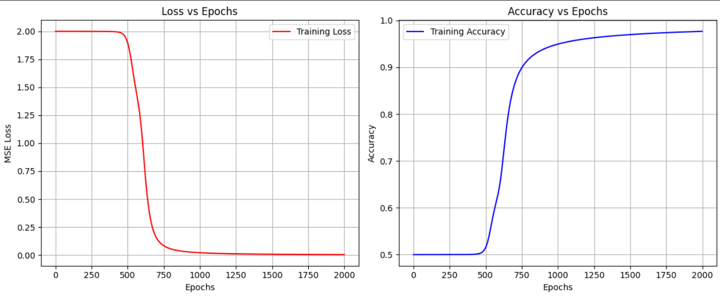
Figure 1 Training metrics

Decision Boundary
To visualize the non-linearity of the solution, we plotted the decision boundary. Figure 2 demonstrates that the network successfully learned a curved boundary to separate the classes (0 vs 1), which proves the effectiveness of the hidden layer and non-linear activations.
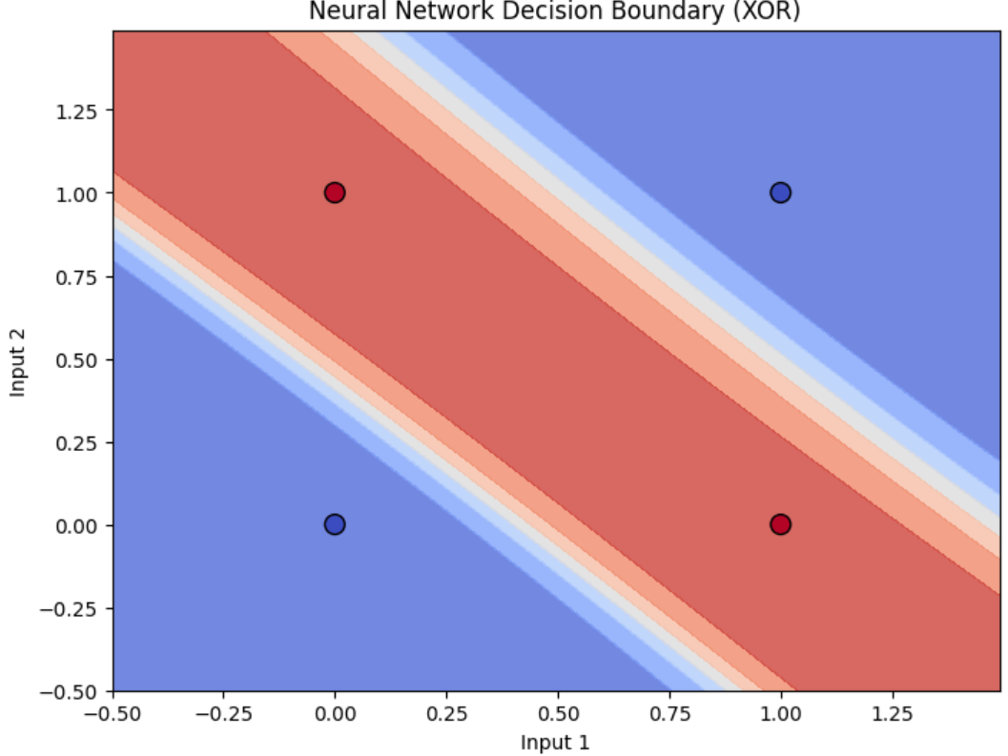
Figure 2 The learned decision boundary separating the XOR classes.

Final Predictions
After training, the model was evaluated on all 4 possible inputs. The results are perfect, meeting the validation goal:
Input A | Input B | Target | Predicted Probability | Rounded Output
0 | 0 | 0 | 0.0229 | 0
0 | 1 | 1 | 0.9764 | 1
1 | 0 | 1 | 0.9803 | 1
1 | 1 | 0 | 0.0266 | 0

Results and Analysis using TensorFlow
Training metrics on TensorFlow showing the convergence of Loss and the improvement of Accuracy over time are coming at a much faster rate than our model.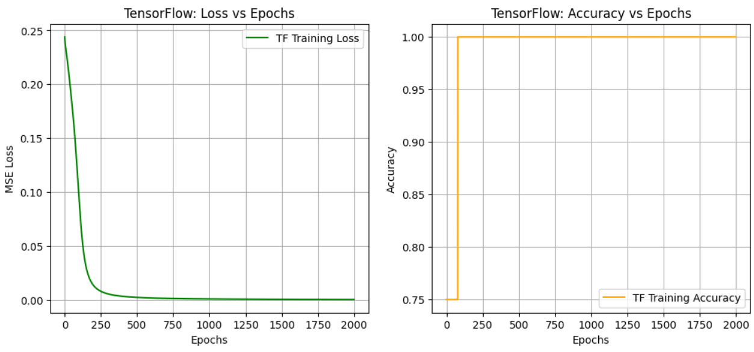
Figure 3 Training metrics on TensorFlow

And it gets almost the same predative answer only on 1 alteration
Final TensorFlow Predictions:
1/1 ━━━━━━━━━━━━━━━━━━━━ 0s 250ms/step
Input: [0. 0.], Pred: 0.0199, Rounded: 0
Input: [0. 1.], Pred: 0.9801, Rounded: 1
Input: [1. 0.], Pred: 0.9837, Rounded: 1
Input: [1. 1.], Pred: 0.0221, Rounded: 0
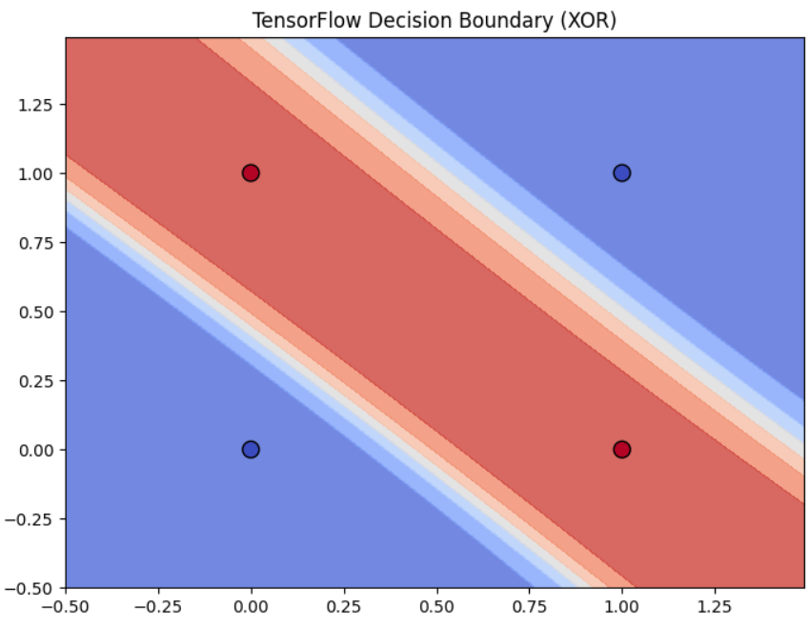
Figure 4 The learned decision boundary separating the XOR classes using the TensorFlow library.

Conclusion
The successful convergence on the XOR problem validates that the core components of the library specifically matrix multiplication in Dense layers and the chain rule implementation in backward propagation are mathematically correct. The library is now ready for complex tasks like image reconstruction.

GitHub repo
https://github.com/minaashraf9822/Computational-Intelligence-project-Fall-2025

Appendix

Code Structure
📂 Repository StructureThe project follows the mandatory structure required by the course: Plaintext/
├── lib/ # Custom Neural Network Library
│ ├── **init**.py
│ ├── layers.py # Dense Layer implementation
│ ├── activations.py # ReLU, Sigmoid, Tanh
│ ├── losses.py # MSE Loss & Prime
│ ├── optimizer.py # SGD Optimizer
│ ├── network.py # Network class (train/predict loops)
│ ├── encoder.py # Encoder Architecture helper
│ ├── decoder.py # Decoder Architecture helper
│ ├── data_loader.py # MNIST loading & preprocessing
│ └── training_history.py # Visualization tools
│
├── notebooks/
│ └── project_demo.ipynb # Main Demo (XOR, Autoencoder, SVM) [cite: 101]
│
├── report/
│ └── project_report.pdf # Detailed Analysis & Results [cite: 95]
│
├── .gitignore
├── README.md
└── requirements.txt

